**Spike:** 11

**Title:** Messaging

**Author:** Michael Williams, 7668481

**Goals / deliverables:**

* Code
* To expand the simple messaging system to support announcements and blackboards.
* To avoid refactoring old code as much as possible to support the new classes.
* Messaging Specification (Announcement and Blackboard aspect)

**Technologies, Tools, and Resources used:**

* Visual Studio IDE

**Tasks undertaken:**

* Decide on the specifications for the additional functions.
* Implement the functionality.
* Test the functionality.

**What we found out:**

We found out how simple it is to expand the messaging system to support announcements and blackboards. We decided on a very simple structure in order to give rise to the additional functionality. When an announcement happens, it is received by everyone, even the sender. It is then up to the recipient to determine if the message is for them, if it is, what should they do with it. In order to achieve this, we added a simple case where the recipient IS the sender.

In order to support the blackboard aspect, each Messageable object now has some additional functions. This allows them to decide if they want to receive messages and also a function to check the blackboard. When there is a message on the blackboard waiting for an object, the object gets a counter incremented so it knows how many messages it has pending.

Please see screenshots below:

Announcements

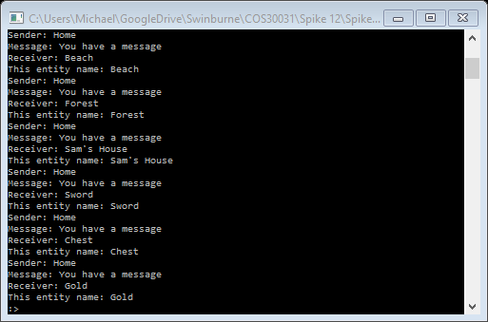

Blackboard Functionality

